

Azure SQL Database

Hands-On Lab

Configuration Guide  
Version 1.0

11/12/2015

Prepared for: Guy Haycock

Azure SQL Database

Prepared by: Prowess Consulting

Table of Contents

Architectural Overview 3

Lab-Configuration Prerequisites 3

Connecting Your Azure Account 5

Deploying a New WingtipTickets Tenant Environment 7

Appendix: Explanation of New-WTTEnvironment Parameters 12

Appendix: Explanation of Web.config Properties 13

Table of Contents

Architectural Overview 3

Lab-Configuration Prerequisites 3

Auto-Provision a WingTipTickets Site Day 1 and Day 2 5

# Architectural Overview

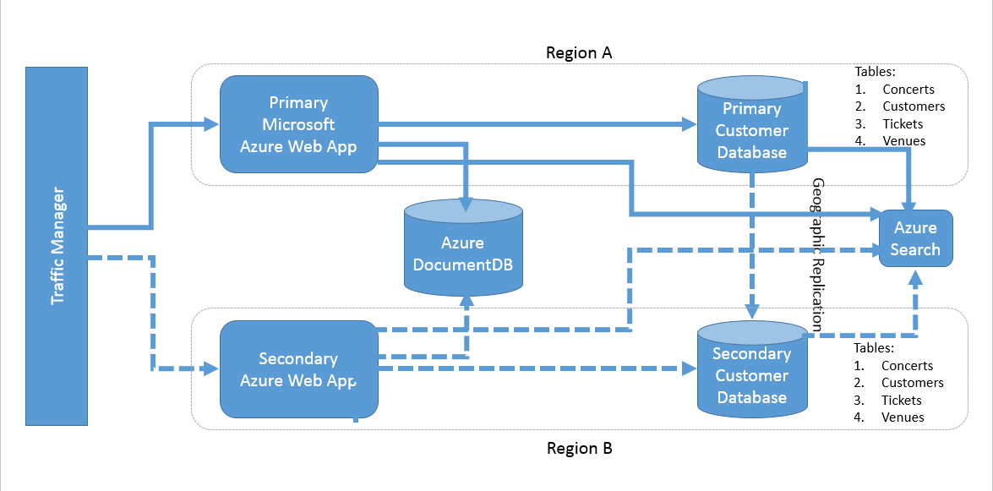

**Figure 1** Overall architecture of the various lab components

# Lab-Configuration Prerequisites

**Table 1** Lab-configuration prerequisites and setup instructions

| **Prerequisite** | **Setup instructions** |
| --- | --- |
| **Microsoft account** | 1. If you don’t already have a Microsoft account, browse to [http://account.live.com](http://account.live.com/). 2. Click **Sign up now**. |
| **Microsoft Azure account** | 1. If you don’t already have an Azure account, browse to <http://azure.microsoft.com/en-us/pricing/free-trial/>. 2. Click **Try it now**. |
| **Microsoft Azure PowerShell** | 1. Browse to <http://azure.microsoft.com/en-us/downloads/>. 2. Under **Command-line tools**, **Windows PowerShell**, click **Install**. 3. Verify that the version being installed is at least 0.9.7 (released August 24, 2015). |
| **Deployment scripts** | 1. Unzip **scripts.zip** to a local folder (for example, C:\scripts). |
| **Microsoft Power Query for Excel (optional)** | 1. If Power Query for Excel is not installed, and you’d like to complete the Auditing section in the hands-on lab (HOL) manual, download and install Power Query from <https://www.microsoft.com/en-us/download/details.aspx?id=39379>. |
| **Microsoft SQL Server Management Studio (optional)** | 1. If SQL Server Management Studio is not installed, and you’d like to run queries against the databases, download and install SQL Server Management Studio from <https://www.microsoft.com/en-us/download/details.aspx?id=42299>. The package is listed as **SQLManagementStudio_<X86/X64>_ENU.exe**. |
| **Microsoft Visual Studio (optional)** | 1. If Visual Studio is not installed, and you’d like to explore any of the source code, download and install Visual Studio from <http://go.microsoft.com/?linkid=9832446&clcid=0x409>. 2. Unzip **sourcecode.zip** to a local folder (for example, C:\sourcecode). |
| **Microsoft Azure .NET software-development kit (SDK) (if installing Visual Studio)** | 1. Browse to <http://azure.microsoft.com/en-us/downloads/>. 2. Under **SDKs**, **.NET**, select the installer for your version of Visual Studio (for example, **VS 2013 Install**). |

# Auto-Provision a WingTipTickets Site Day 1 and Day 2

This configuration guide will walk you through the process of deploying the WingTipTickets tenant website for Day 1 and Day 2 of the Data Camp event. Day 1 covers deploying the initial WingTipTickets platform, which utilizes Azure Web App, Microsoft Azure SQL Database, Azure Search, and Azure DocumentDB services. Day 2 covers deploying the additional Azure Data Factory services.

1. Clear your browser’s cookies and cache, and then close the browser.
2. Open a new browser, navigate to <http://wingtipticketsprovisioning.azurewebsites.net/datacamp>, and then click **Create Account Day 1**.

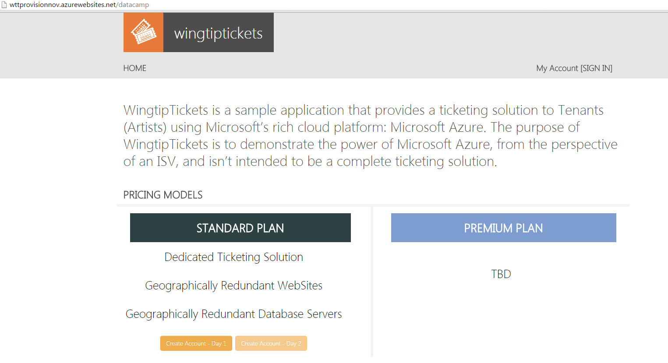

1. Click **Work or school account** or **Microsoft account**, based on your account type.

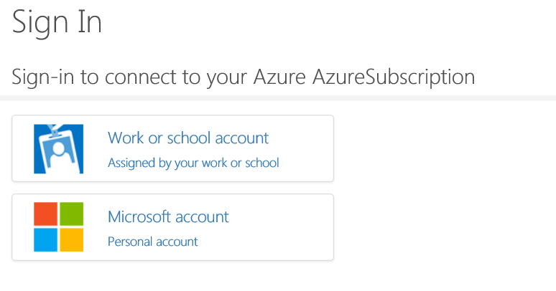

1. Type your **Directory name** as shown in the following example.

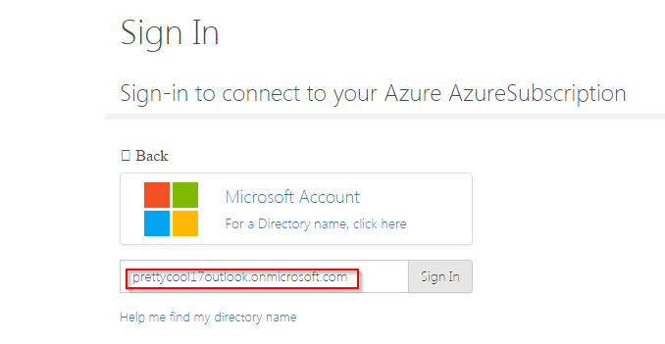

You can use the following procedures to find your Directory name:

**Method 1**

* 1. Log on to <https://manage.windowsazure.com>.
  2. On the left-hand pane, click the **Active Directory** icon.
  3. On the right-hand pane, click the **Default Directory** of the listed directory.
  4. Click **Domain**.

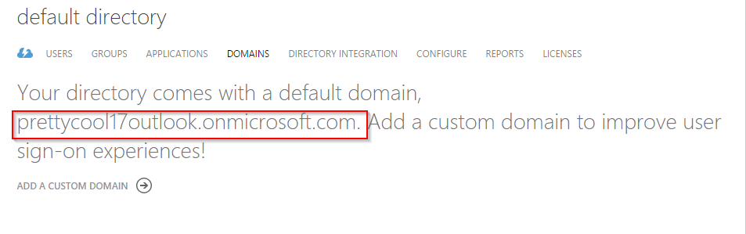

**Method 2**

1. Log on to <https://manage.windowsazure.com>.
2. On the left-hand pane, click the **Settings** icon.
3. On the right-hand pane, **Directory Name** is shown under **Default Directory** of the listed directory. It is also shown in the browser’s Address bar.

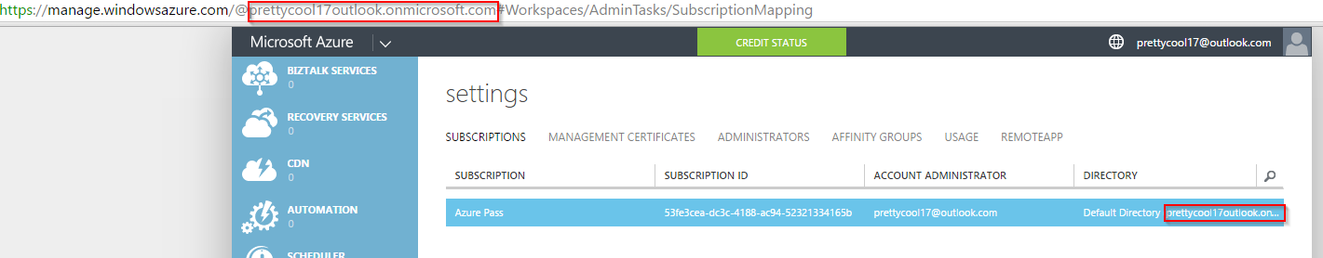

1. Click **Accept** to allow the AutoProvisioner application to provision the WingTipTickets application into your subscription.

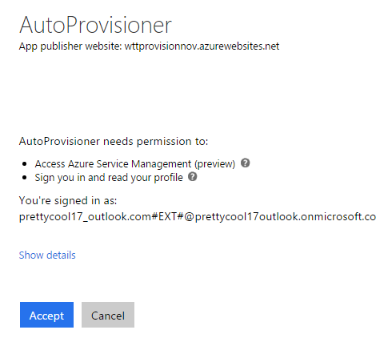

1. Enter the following details:
   * First Name*
   * Last Name*
   * Site Theme*
   * Location*  
     **Note**:The Location field specifies the data-center region that will be targeted for the deployment. If the selected location does not support Db v12.0, the next compatible region will be automatically assigned for the tenant.

*\* Denotes mandatory fields*  
 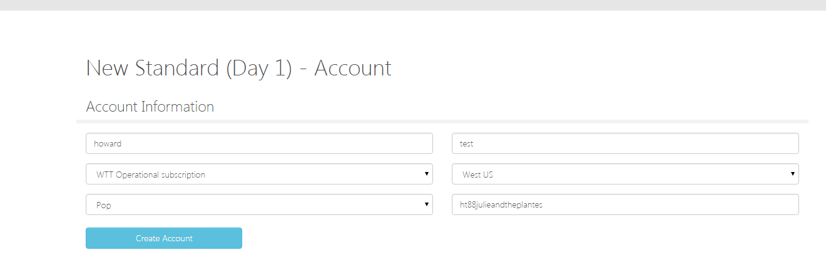

**Note**:The read-only SiteName field will be automatically generated based on the First Name and Last Name fields, in addition to the selected Site Theme.

1. Once the tenant details have been captured, click **Create Account**.

The tenant account is then created and the user is taken to the Account Information page. A list of Azure services is displayed along with the services’ real-time provisioning statuses. Once each service has been successfully created, its status will change to “Deployed.”

**Note**: Database servers and website components have primary and secondary (fail-over) servers. Routing for this is handled by the traffic-manager component.

1. Click **Start Provisioning** to start deployment. Allow 16–20 minutes for all services to deploy.

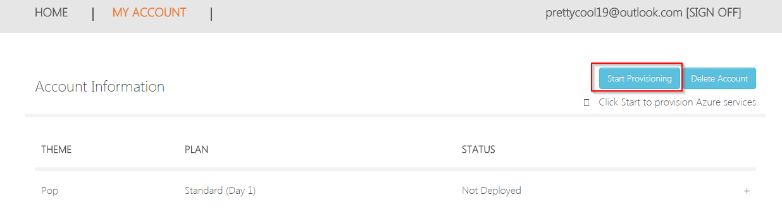

1. Once all the services are deployed, provisioning has completed successfully, and the tenant site can be accessed by clicking **Open Tenant Site**.

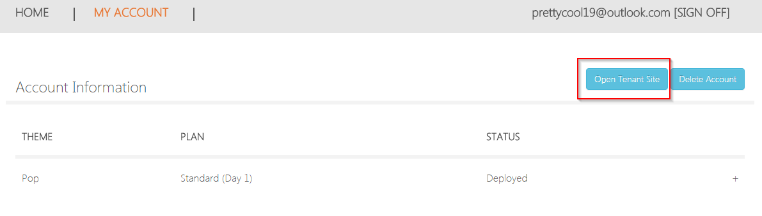

**Note**: If there are errors, a **Retry Provision** button will appear, which enables you to retry the provisioning.

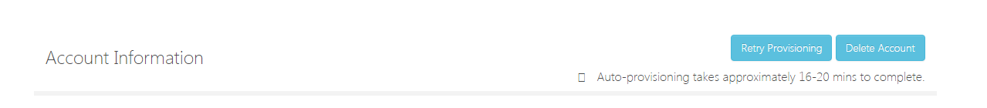

You can also click **Delete Account** if you want todelete your resources and start over.

1. Go to <http://wttprovisionnov.azurewebsites.net/datacamp>, and then click **Create Account Day 2**.

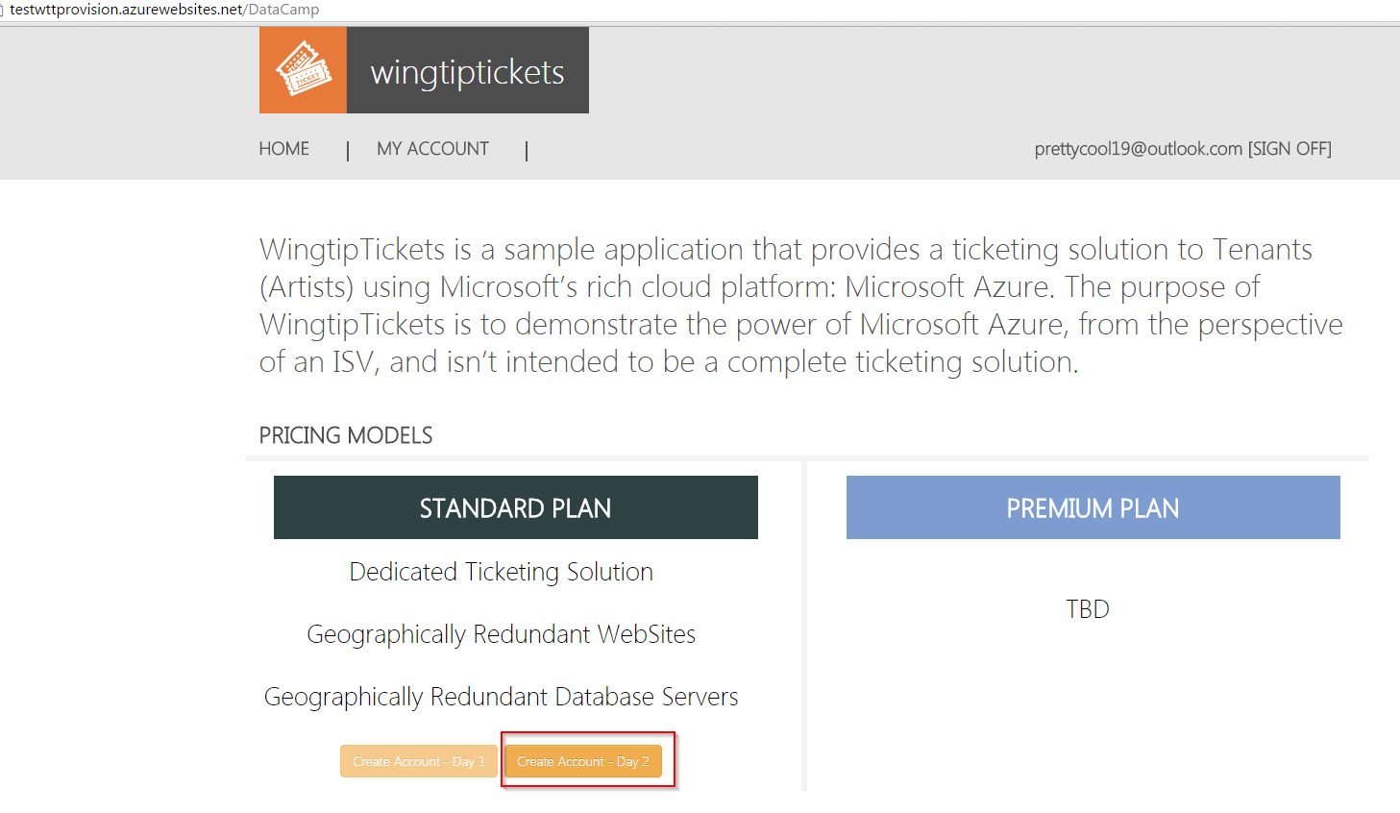

1. Pick a location, and then click **Create Account**.

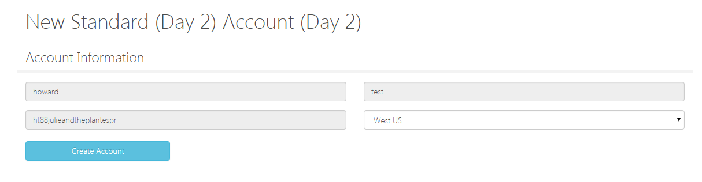

1. Click **Start Provisioning** to start Day 2 provisioning.

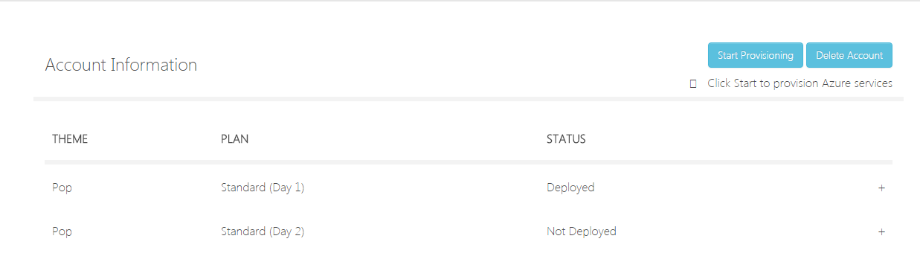

1. Once all the services have been deployed, provisioning has been successful, and the tenant site can be accessed by clicking **Open Tenant Site**.

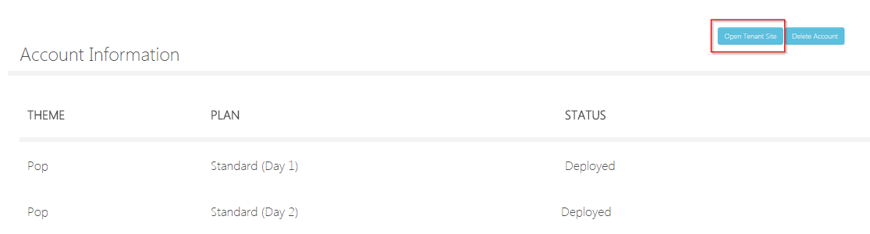

**Note**: If there are errors, a **Retry Provision** button will appear, which enables you to retry the provisioning.



You can also click **Delete Account** if you want todelete your resources and start over.